Rector’s Report
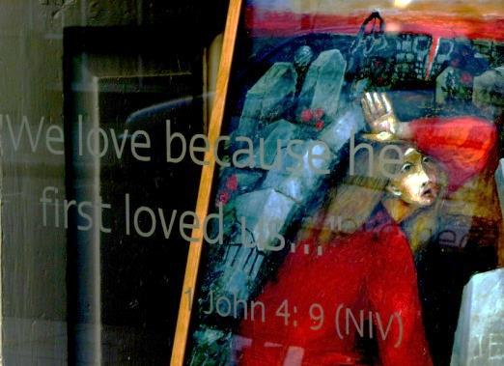

The weeks following the Annual meeting last year saw the completion of the second phase of the Building refurbishment and reordering. We are grateful to everyone who has given and continues to give in support of this project.

At that meeting, I referred to John 15: 4-10 which I believe has important things to say to us:

The Message Bible puts it this way:
⁴ “Live in me. Make your home in me just as I do in you. In the same way that a branch can’t bear grapes by itself but only by being joined to the vine, you can’t bear fruit unless you are joined with me.
⁵⁻⁸ “I am the Vine, you are the branches. When you’re joined with me and I with you, the relation intimate and organic, the harvest is sure to be abundant. Separated, you can’t produce a thing. Anyone who separates from me is deadwood, gathered up and thrown on the bonfire. But if you make yourselves at home with me and my words are at home in you, you can be sure that whatever you ask will be listened to and acted upon. This is how my Father shows who he is—when you produce grapes, when you mature as my disciples.
⁹⁻¹⁰ “I’ve loved you the way my Father has loved me. Make yourselves at home in my love. If you keep my commands, you’ll remain intimately at home in my love. That’s what I’ve done—kept my Father’s commands and made myself at home in his love.
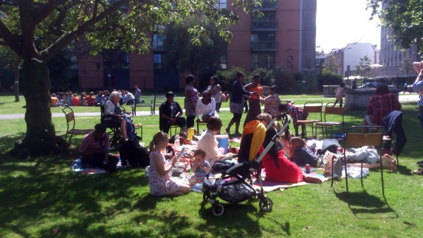
Jesus is making a point about the importance of being connected:
- To God
- To Jesus
- To Each other

Is that not what Paul meant when he said:
”Now you are the body of Christ, and each one of you is a part of it” (1 Cor 12: 27)
Here are some of the different ways (outside the normal run of events, such as services on Sundays, at Christmas, Easter, Festivals + Baptisms, Confirmations, Weddings and Funerals) in which we have “connected” in one way or another over the last year:
2013
- January to May: Just10.5+5
After Easter 2013 approximately 30 people concluded this study of the 10 Commandments
In Madness Youth group, in small groups, in homes.

The Commandments were also part of a Sermon series in church on Sundays and as a series at Boutcher School.

- Service of Celebration and Thanksgiving for the Completion of the Building work Phases 1+2: 9th June, for St Mary’s friends and church family:
- Faith on Film nights: 27th June and 4th , 18th + 25th July
- Deanery Confirmation service: 7th July.
- Church Open Evening for Businesses and Residents
in the local community: 11th July.
- Bermondsey Street Festival: 21st September
- Service of Re-Dedication of our Building including the recently re-ordered spaces with Bishop Michael of Woolwich: 22nd September
- Church Weekend Away at Latimer House: 25th – 27th October.
The theme of the weekend was “Living Free” led by Revd Bill Wilson and Mae Cleaver from St Stephen’s, South Lambeth (See Jesus Ministry Report)
- Choral Evensong for Advent with the Charpentier Consort: 8th December.

2014
- Choral Compline: 5th February 2014 (the next Choral Evensong is on 11th May)
- LivingFREE course with St Stephen’s South Lambeth: 9th February – 30th March
- Home Prayer meetings: January to April
- Saturday Breakfast Prayer meetings: January to April
- Showing of “The Passion” film during Lent: 19th + 27th March and 10th+16th April.
- Good Friday Meditation- Creative Installations prepared by the St Mary’s Madness! Youth group and facilitated by Eugene Ankomah of the Salmon Youth Centre. Church open on Friday 18th and Saturday 19th April (see photos below).

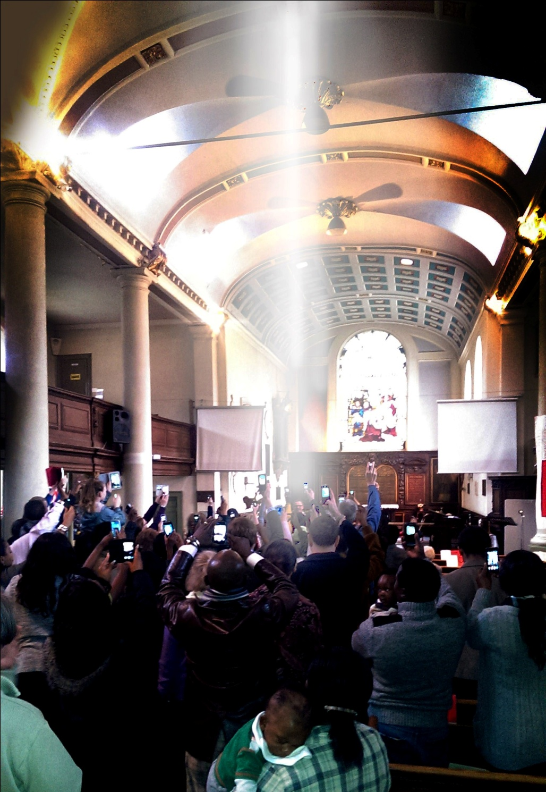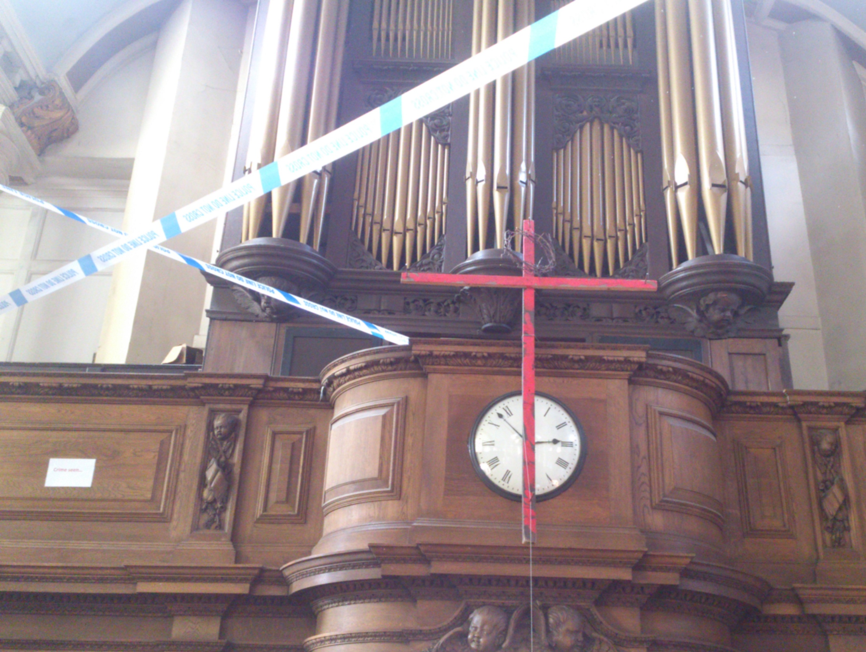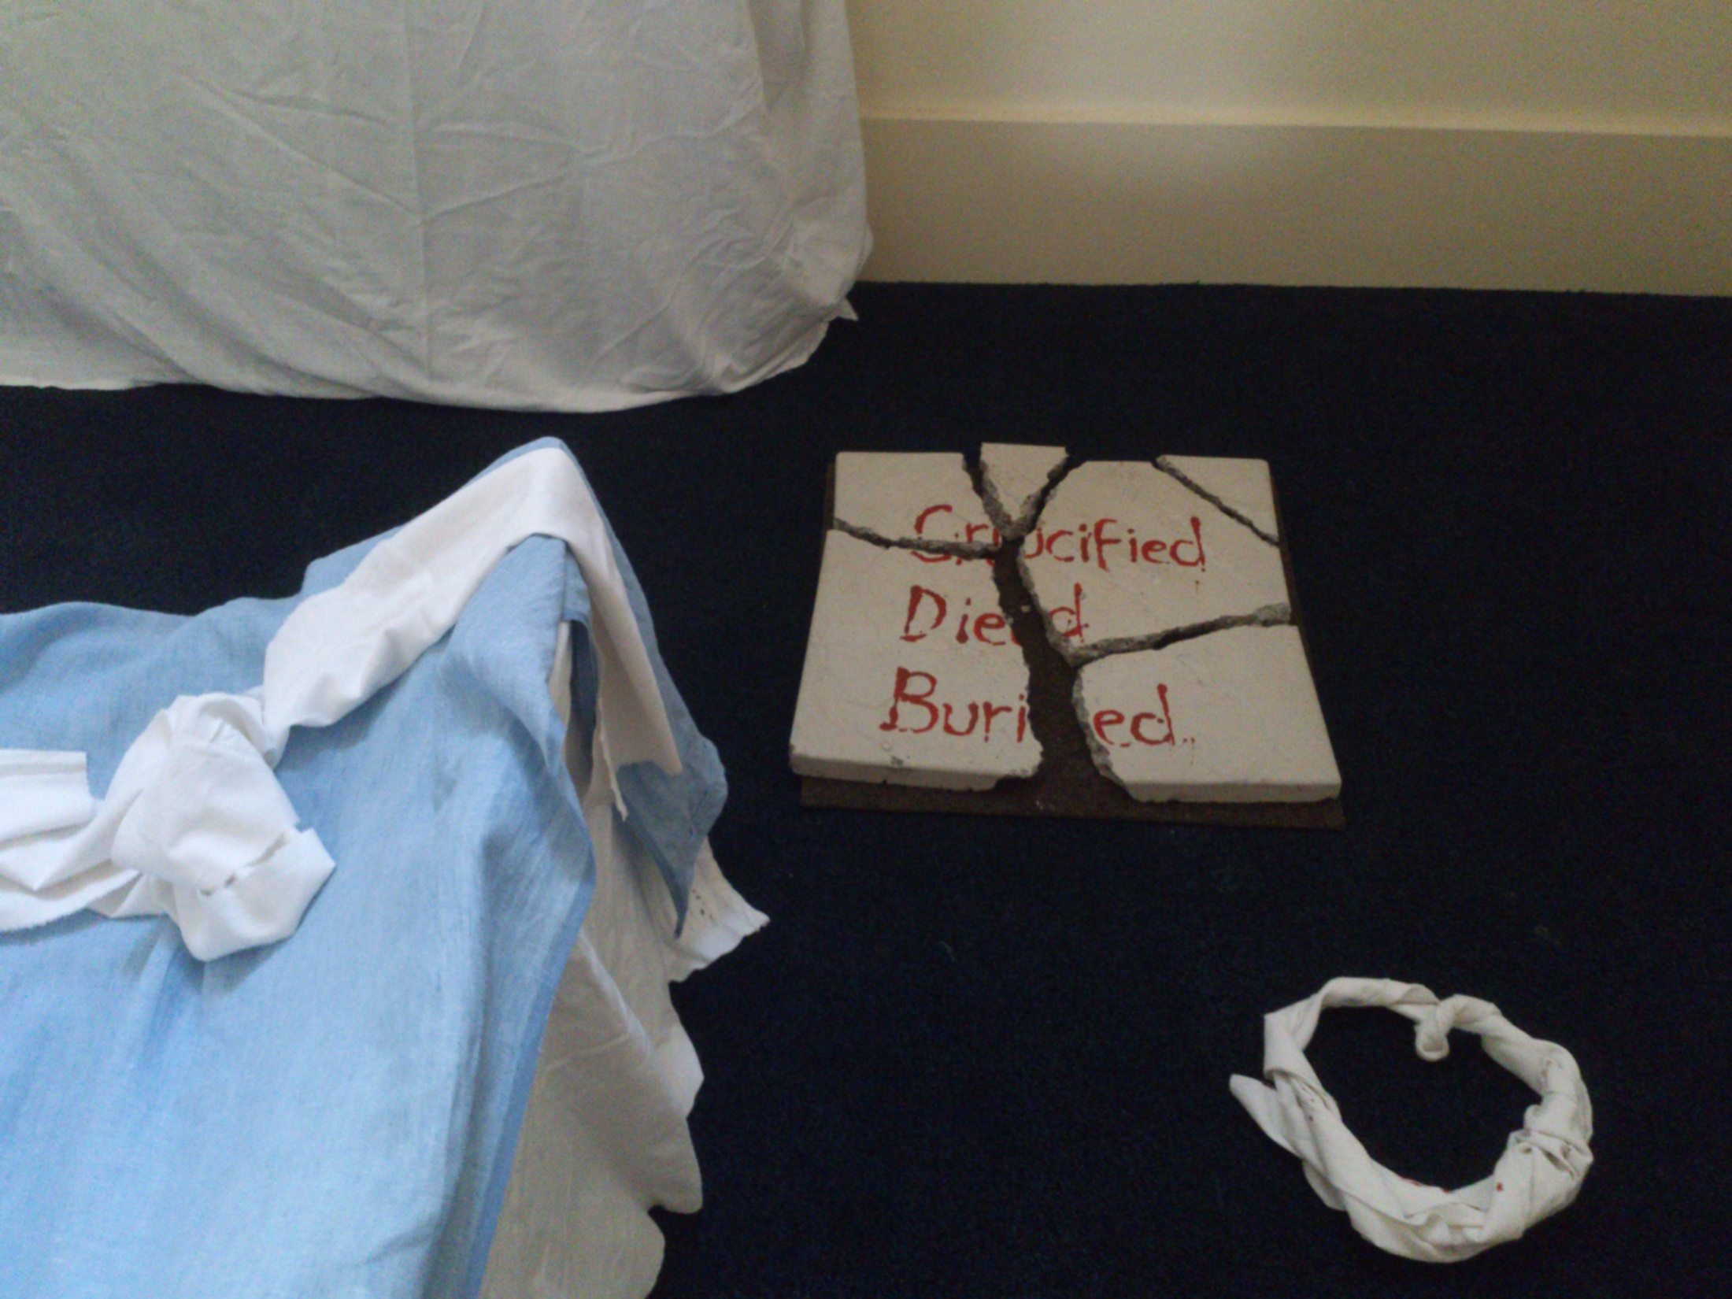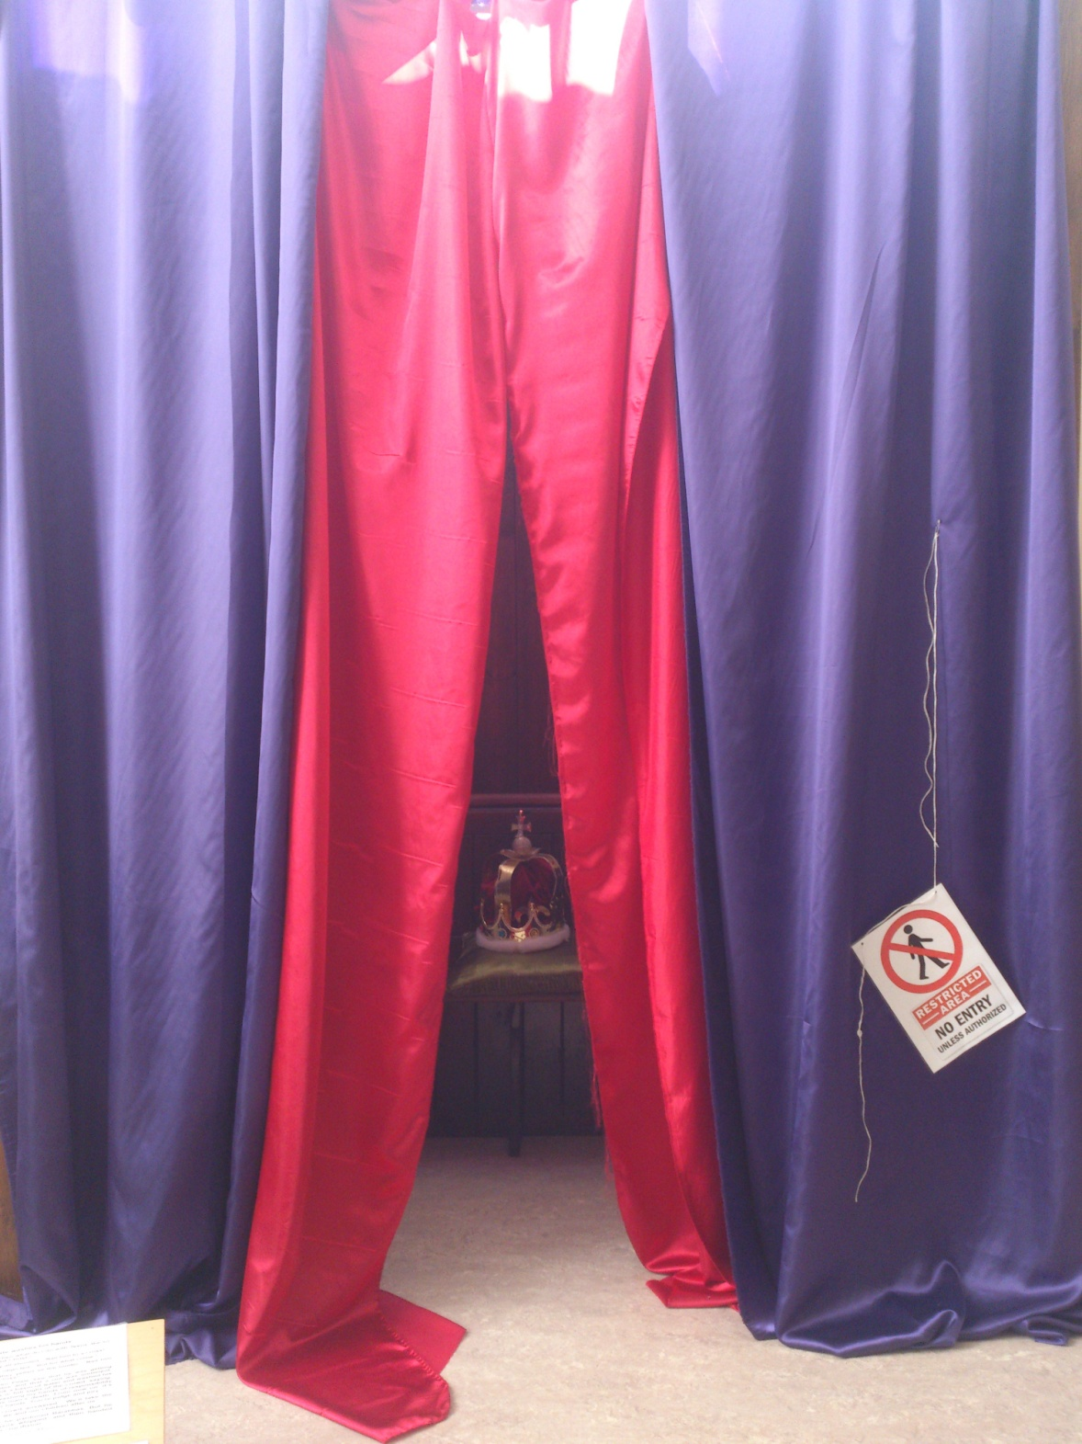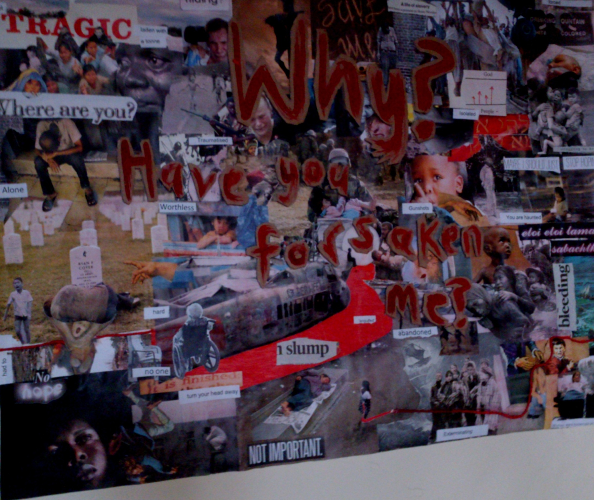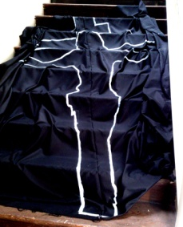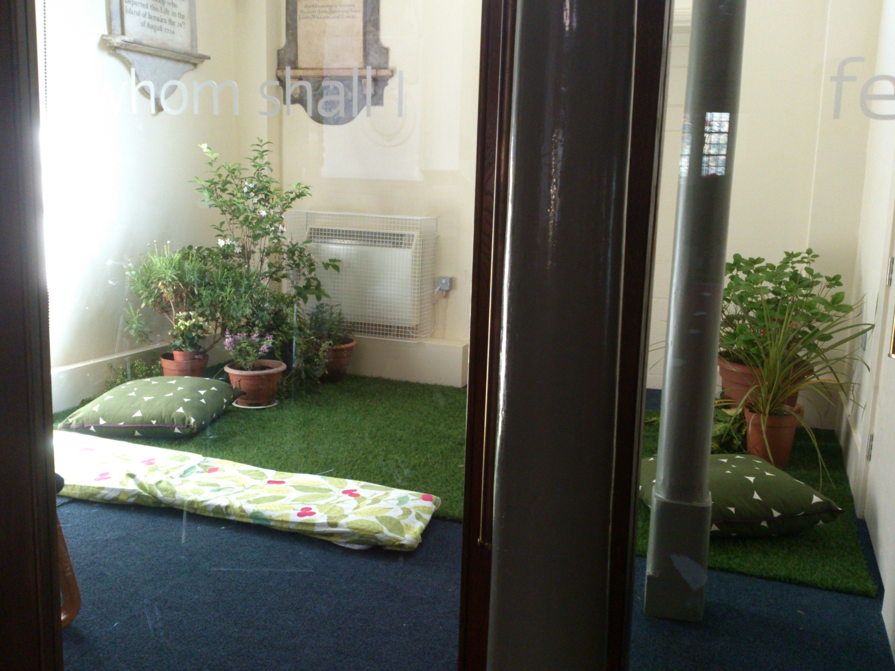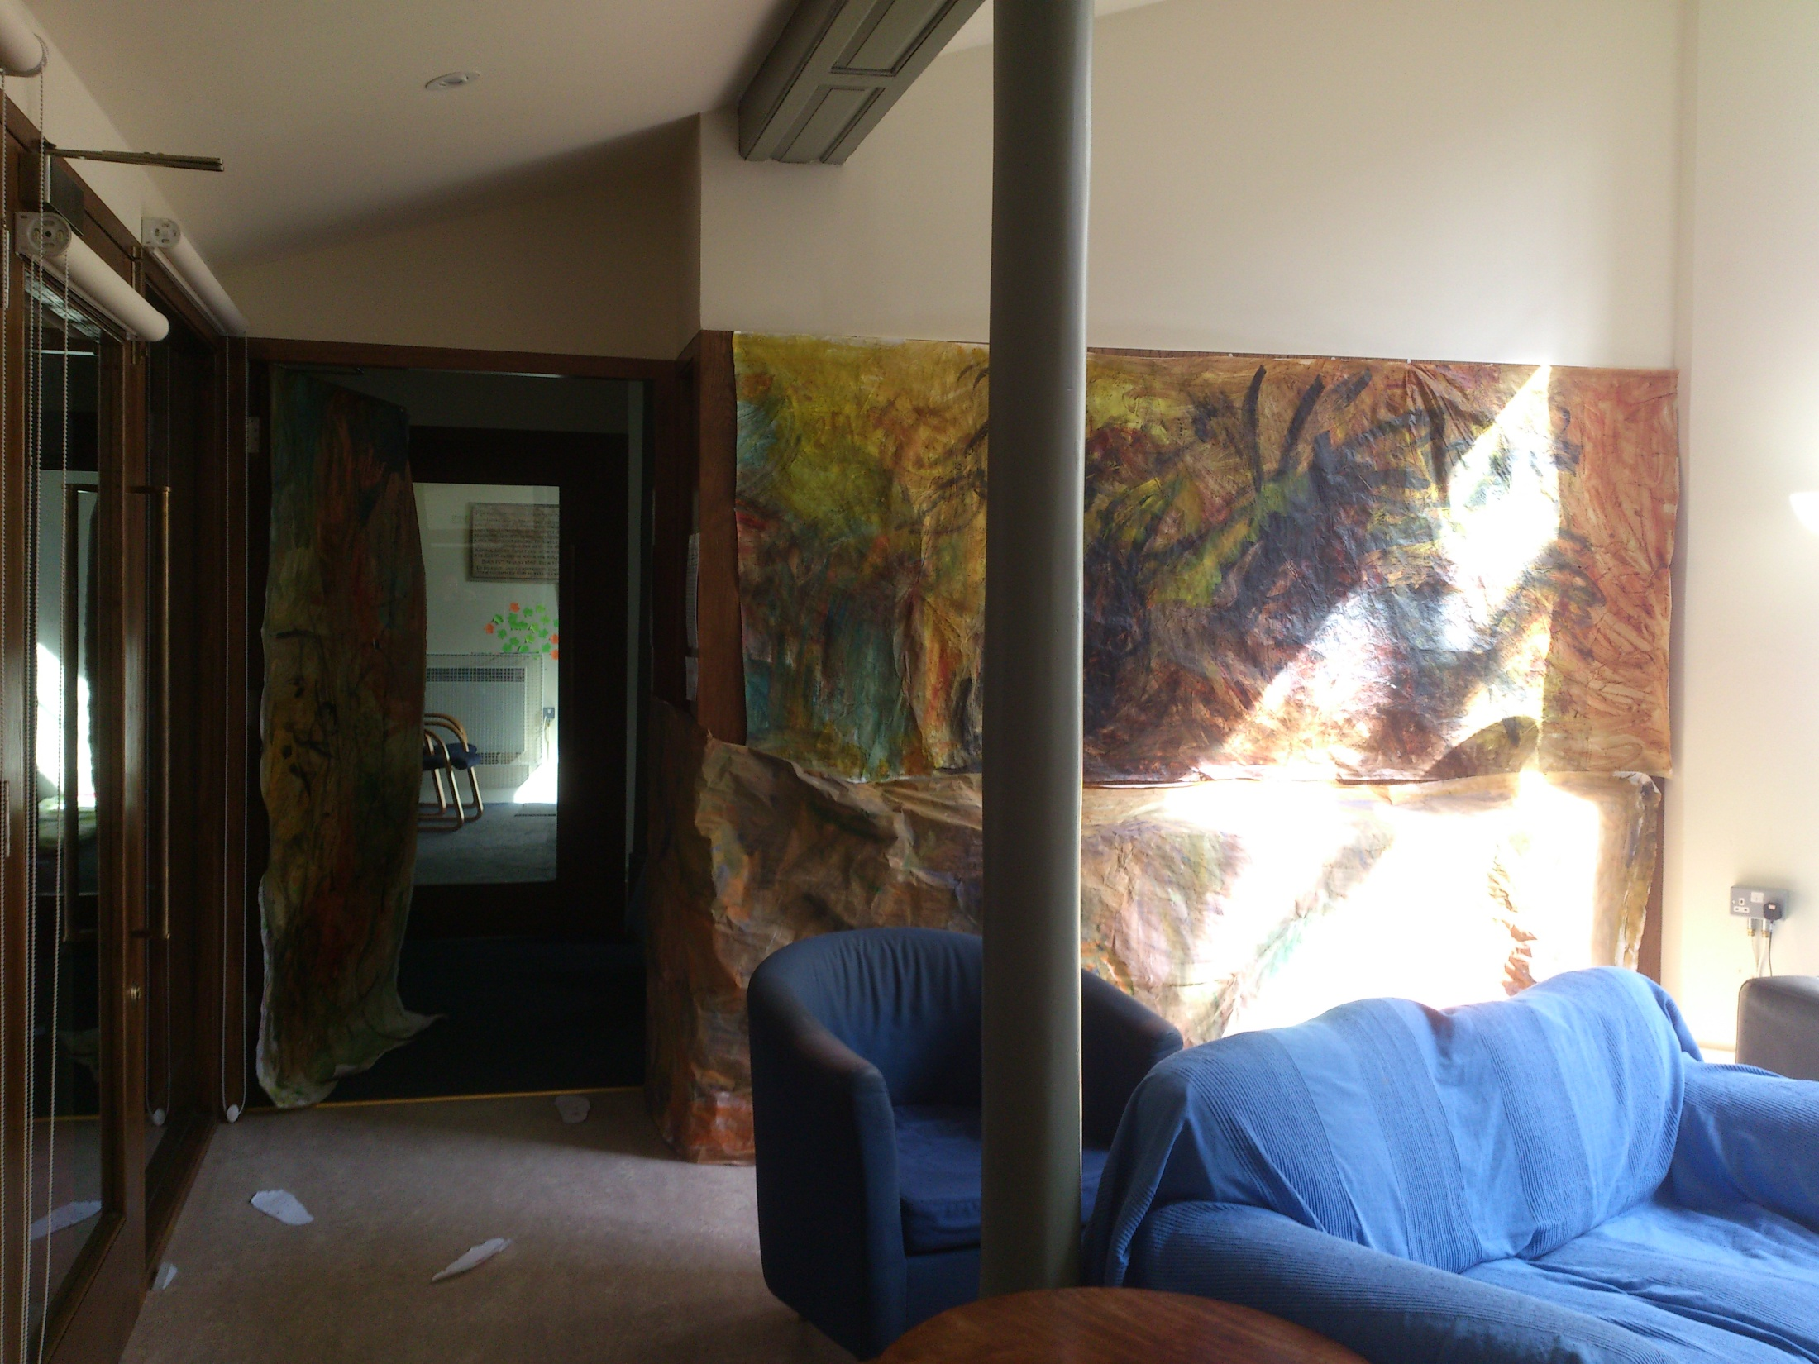

One of the main aims of opening up the church building was to increase connectivity between ourselves, as well as with the community in which we live, worship and work.
The following pictures help show, to what degree this has been successful architecturally.

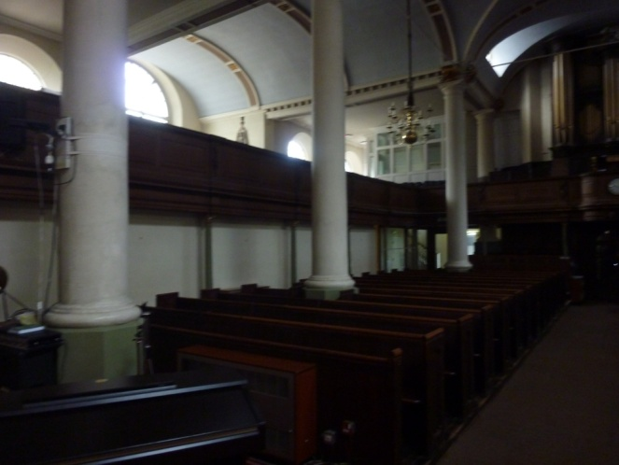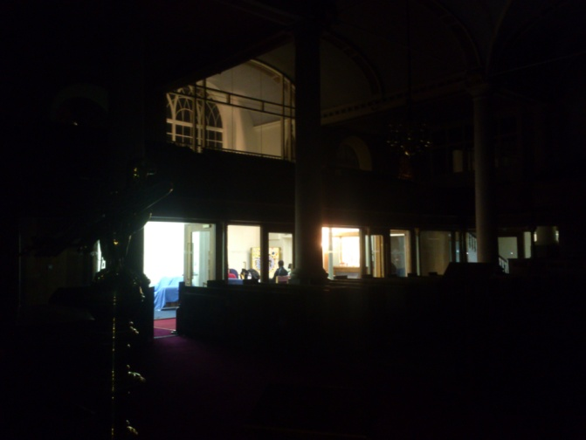
Before After
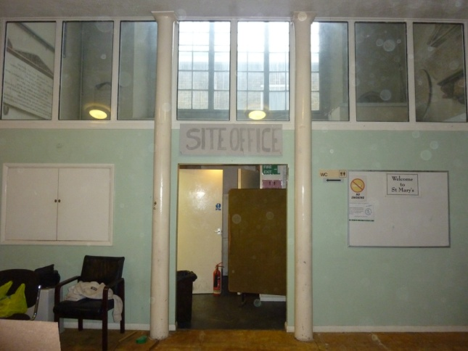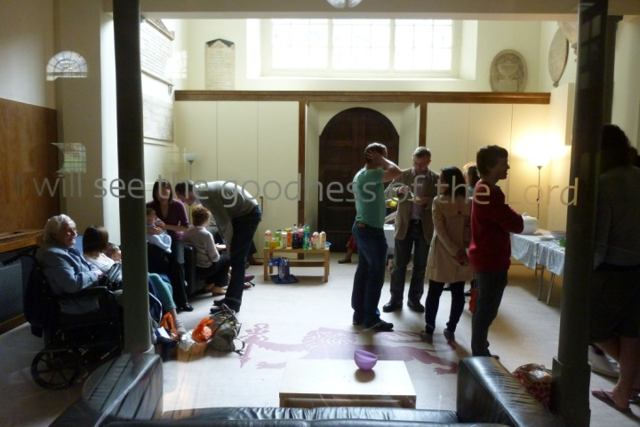
Before After
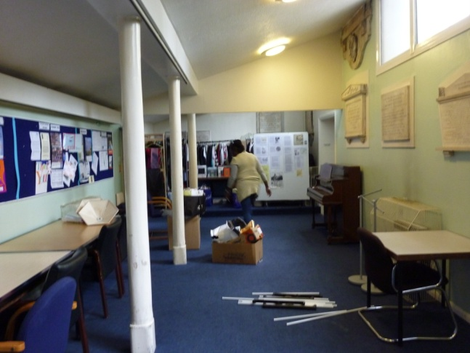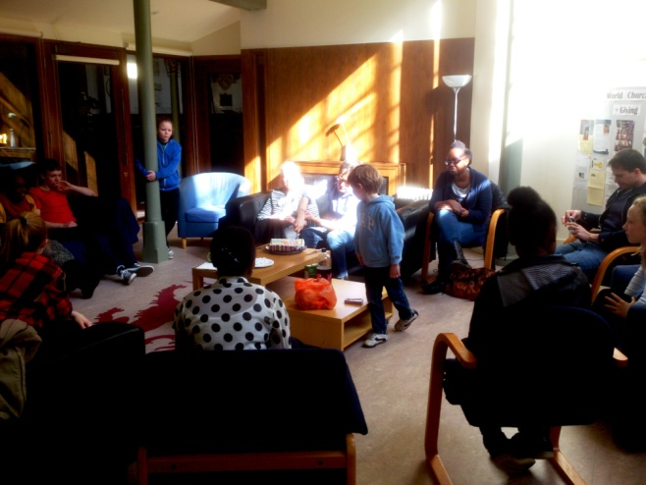
Before After

What we see architecturally, however, is only a small glimpse of what we want to see spiritually…. What we do in our own strength, while good, is only a fraction of what can be achieved when we give our plans to God.

What are we to do?

It is interesting to look at the disciples and how their attitude and outlook changed as the reality of the resurrection was revealed to them.

When we look at John 20: 9-22 we see that 3 things happened:

- They hid in the upper room with the doors locked (v19-20)

- Then Jesus came to them.

- They received the Holy Spirit and moved out from there together to take the world for him (v 21-22)

Perhaps we are a bit like those disciples: frightened but full of potential.
The Church is called to be different. To counter the culture of Individualism which surrounds us. So, how different does your life look when compared to the life of your non-Christian friends? There should be a difference…
In the words of the late David Watson: “Once a congregation grasps that God has called us collectively as his people so that his glory might be seen in us… they may well be transformed” That’s where connection is important- as Christ’s body, the church. Without Jesus, the head, we would be spiritually dead and so without each other, how can we live on effectively?

Did you know that in some parts of the world, to simply say you are Christian will mean that you lose everything? Your family and friends will reject you and you lose your home, status and job. In such a culture, nominal Christianity simply doesn’t make sense. As one Asian Christian said: “Why would anyone choose that unless he or she is serious about Jesus?”

So the challenge for us today, is to take Jesus seriously just as those early disciples did.

“It’s impossible to be a disciple or a follower of someone and not end up like that person . Jesus said, “A disciple is not above his teacher, but everyone when he is fully trained will be like his teacher” (Luke 6: 40). That’s the whole point of being a disciple of Jesus: we imitate Him, carry on His ministry, and become like Him in the process. Yet somehow many have come to believe that a person can be a “Christian” without being like Christ. A “follower” who doesn’t follow”
(Chan, Francis; Beuving, Mark (2012-11-01). Multiply: Disciples Making Disciple)

In order to help us be more effective individually and collectively, we are going to put together a Mission Action Plan over the next few months (PCC Away Day arranged for Saturday 5th July).

“A Mission Action Plan is a document which outlines the mission activities that a local church is going to do in the coming months and year. It is built on a clear sense of God’s vision for the church – what God is calling the church to be and to do”
(Mike Chew and Mark Ireland- from Mission Action Planning)

Note: this is the about God and not us… for as someone once said: “the local church is the hope of the world” The point of this is being connected
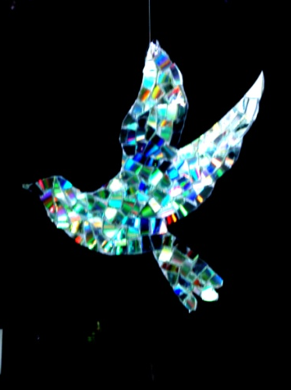
- To God
- To Jesus
- To Each other
Again, as Jesus says in John 15: 5b
“….apart from me you can do nothing”
Charlie Moore: Easter 2014
St Mary’s Church Weekend Away: 25th – 27th October 2013

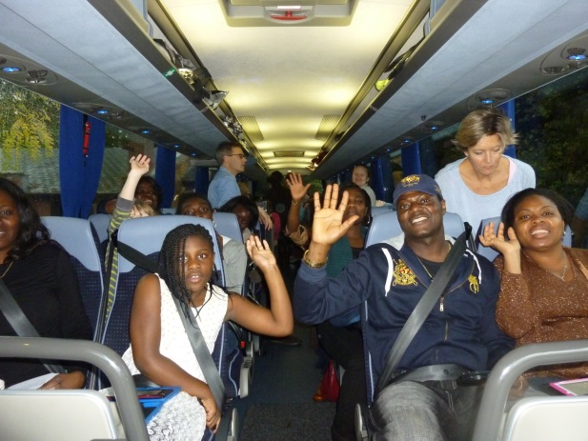

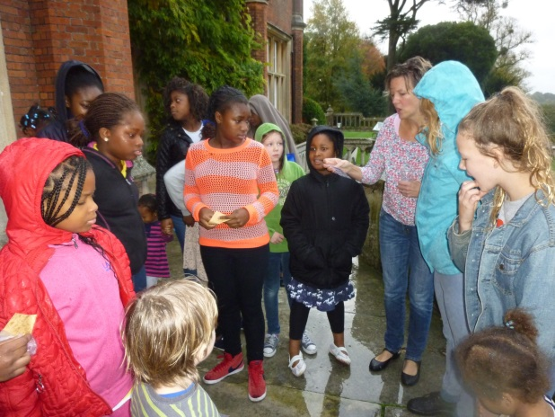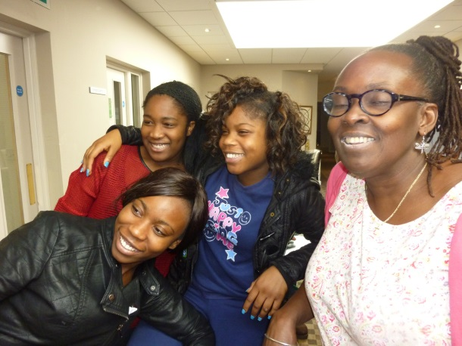

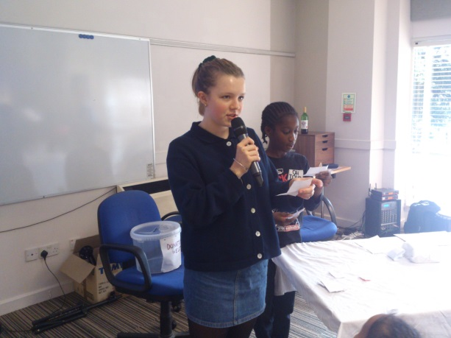
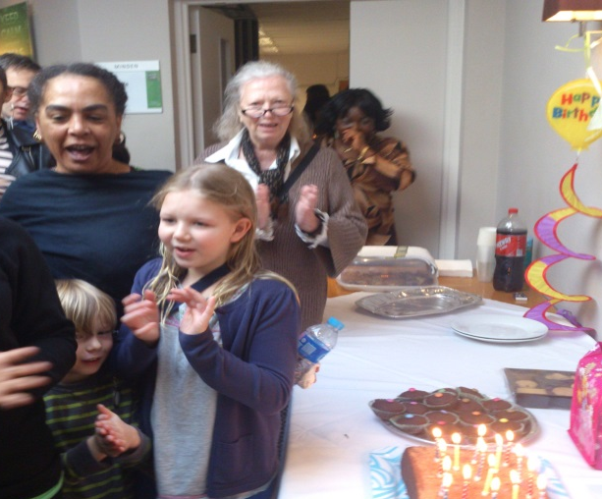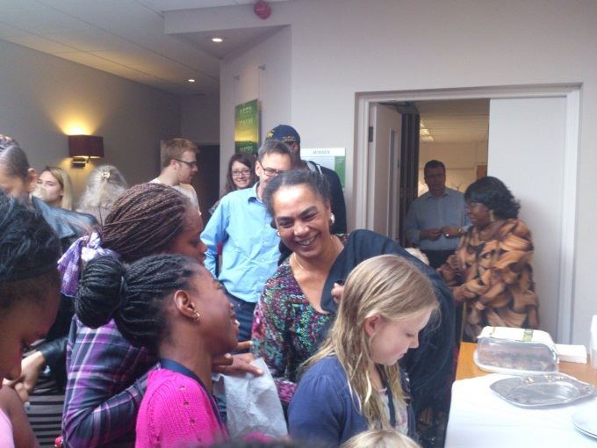

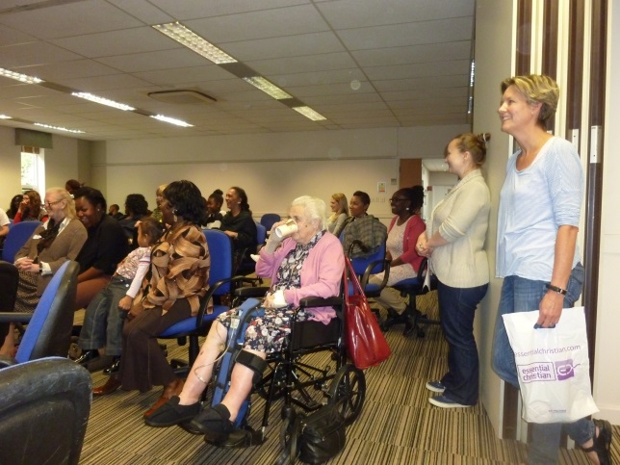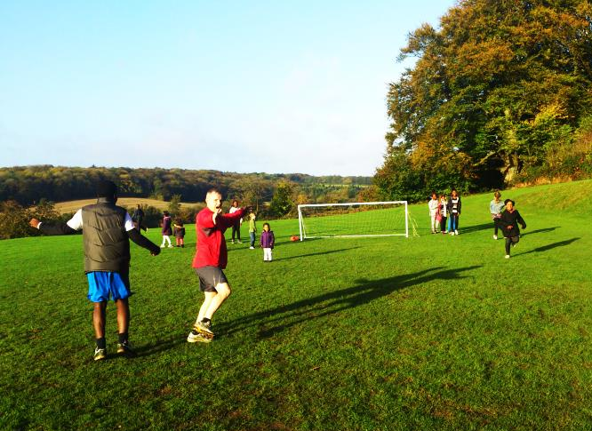

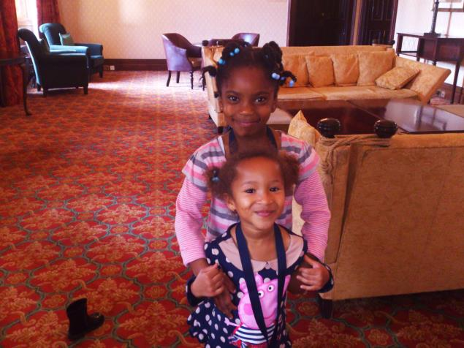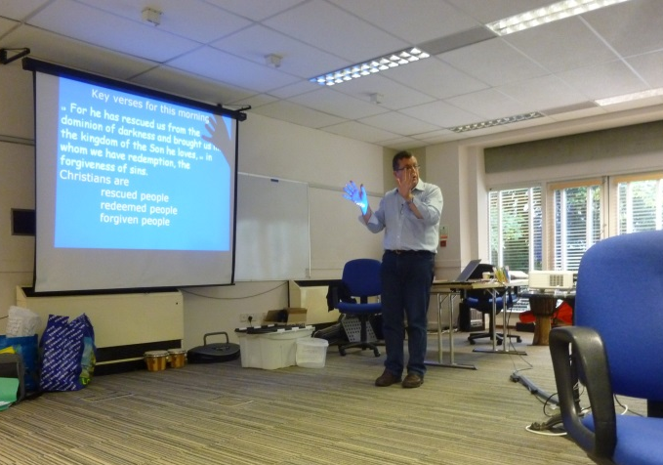

JESUS MINISTRY

In Luke 4, Jesus quoted from Isaiah 61:

Preach the good news to the poor, Bind up the broken-hearted, Proclaim
freedom for the captives and release from darkness for the prisoners;
Proclaim the year of the Lord's favour

The Prayer ministry of Jesus, as related in the Gospels, and when exercised in
the power of the Holy Spirit, will encourage us to:

1. Live with greater perception of the spiritual realm
2. Walk with increased spiritual authority
3. Experience new levels of freedom and joy in the Holy Spirit

During the last year Charlie has continued to attend JM Pastors days at Christ
Church Fulham, we have looked at these principles in more depth on our Church weekend away, and through the completion of the Living Free course by 13 church members.

This will be followed with Prayer appointments for all who attended the course and further opportunities to put the principles into practice in our church life...

Charlie Moore

