RECTOR’S REPORT
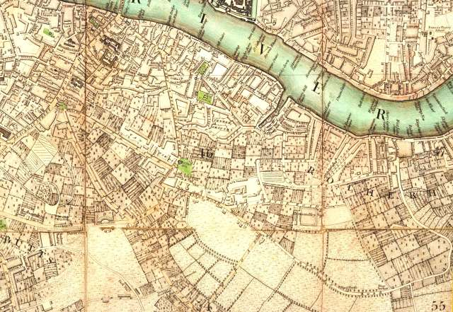
00.12 90
27.01.02
28.04.02
29.04.12
30.04.12
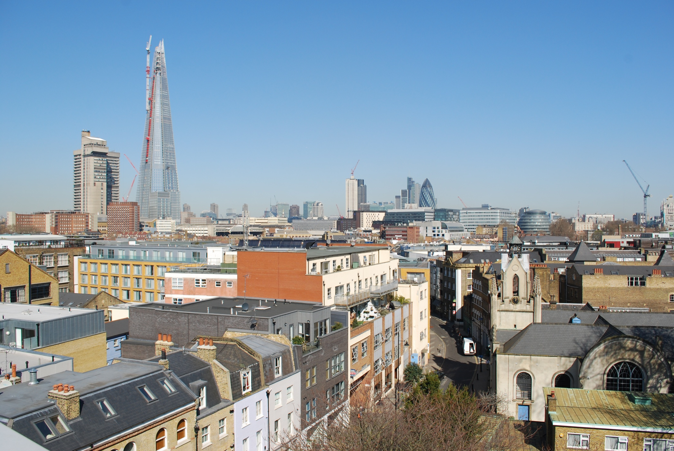

PSALM 127: 1
10 years and 3 months ago, I wrote in my first Annual Report at St Mary’s:

“.....as I come to you from another place, I hope that I have been able to see things from a fresh perspective. In a way it is rather like a new marriage- the wedding has taken place, the honeymoon is over and now the marriage with all its ups and downs, highs and lows, really begins!”

Well, I can assure you that the honeymoon is well and truly over and although there have been ups and downs, we are still together!

On Monday 23rd January 2012, I was asked by the owners of a local restaurant, to pray in their basement bar. As I prepared for that, I could imagine myself standing in the middle of the fields around this church (circa 1290) and I recalled the words of Psalm 24: 1

“the earth is the Lord’s, and everything in it, the world, and all who live in it”

There used to be an Antique shop across the road, in the basement of which, some of the flagstones of the Abbey were reputedly laid on the floor: A rare glimpse of a layer of history not covered by successive developments. When they were excavating the square a few years ago, you could actually see layer upon layer of history representing the life of the city down the generations, right back to Roman times.

These physical layers could also be a metaphor for the Spiritual history of the city, which has been played out across this land through which a river runs.... and that river, the Thames, in turn reminds us of the presence of God.

Yes, God is in this place. This Building, the home of generations of Christians, is, in a way:

a “sacred” place.

When someone asked me recently what my vision for the building was, I said I would like it to be

a “Breathing” space: a place where people can step off the street and out of the race, just for a moment and be reminded of the bigger story.

That story is the one told in this book, the Bible, and I believe that our individual stories can only make sense, in relation to and in the light of that: In this place and in our homes, at our work. These are the places where we can work out together what it means to be Christians.

Yes, this is also:

a “protected” place, not simply as a building because it is old and listed Grade 2*, but because God’s people worship here. Worship is what we do. We worship when we read the Bible and Pray. When we sing praise to God. It takes us to another place. It is a “spiritual” act which is very powerful and yet which we can only do fully when we believe. When we worship, battles are won (see 2 Chronicles 20: 21): against fear, sickness, insecurity... and hope is born, peace experienced, faith grown..... because God is involved.

I will conclude with some words from my Report in 2003:

To quote Jacob in Genesis 28: 17a. After having a dream in which he saw a stairway to heaven, Jacob awoke from his sleep and thought,

“Surely the Lord is in this place and I was not aware of it…..”

Are we aware of it? Next time you sing or pray. Next time you stand in the doorway of St Mary’s, the threshold of this house of God, look back and look forward, look in and look out. What do you see? The door is where we come in and go out. What will we bring and what will we take away? Let us pray that for us, like Jacob, this place, our place, may fully be:

“His” place……

“none other than the house of God…. The gate of heaven” (Genesis 28: 17b)

Charlie Moore: 29th April 2012

